

**North South University**

**Midterm**

**Power Systems**

**Course Code: EEE362**

**Section: 02**

**Course Instructor**

**Hafiz Abdur Rahman (HZR)**

**Prepared By**

|  |  |
| --- | --- |
| Mohammed Mahmudur Rahman | **ID** **#** 152 0386 043 |

Answer to question No :3

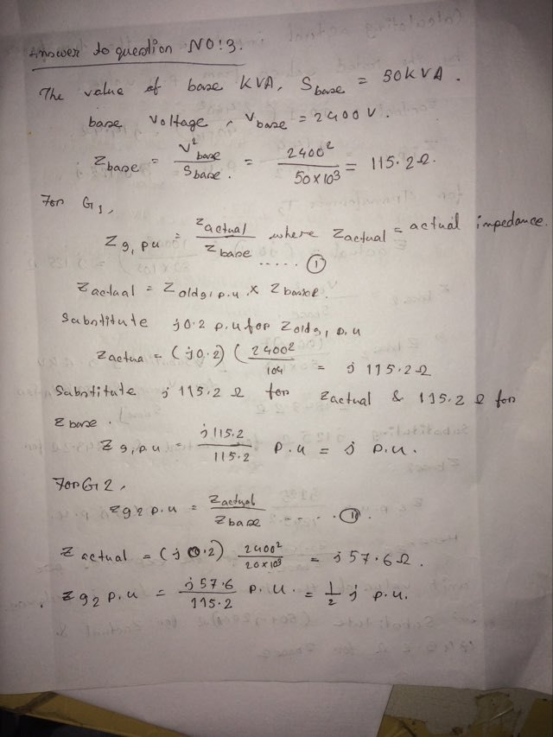

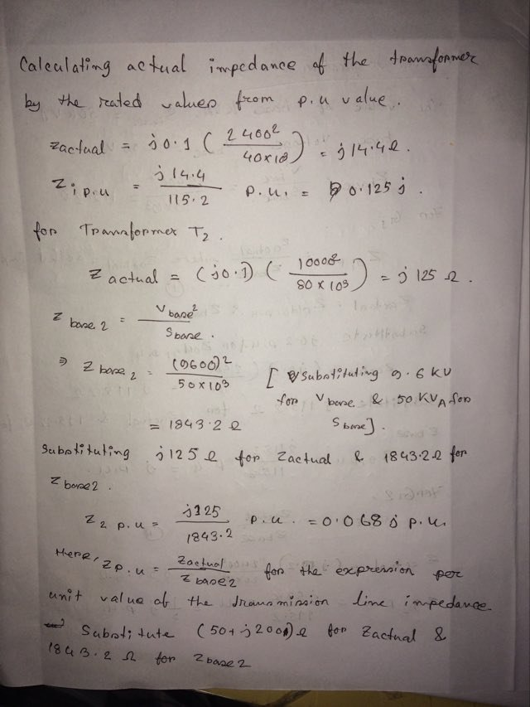

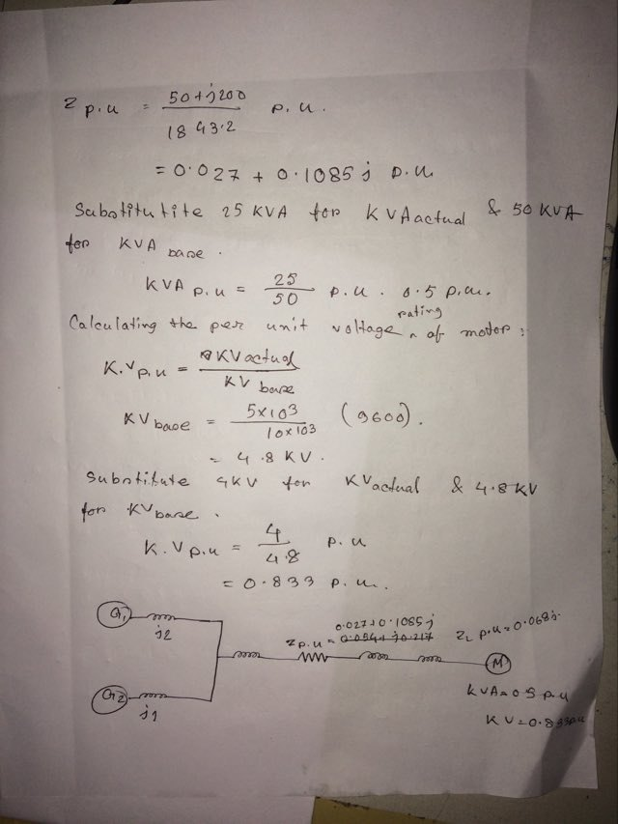

Answer to question No: 2

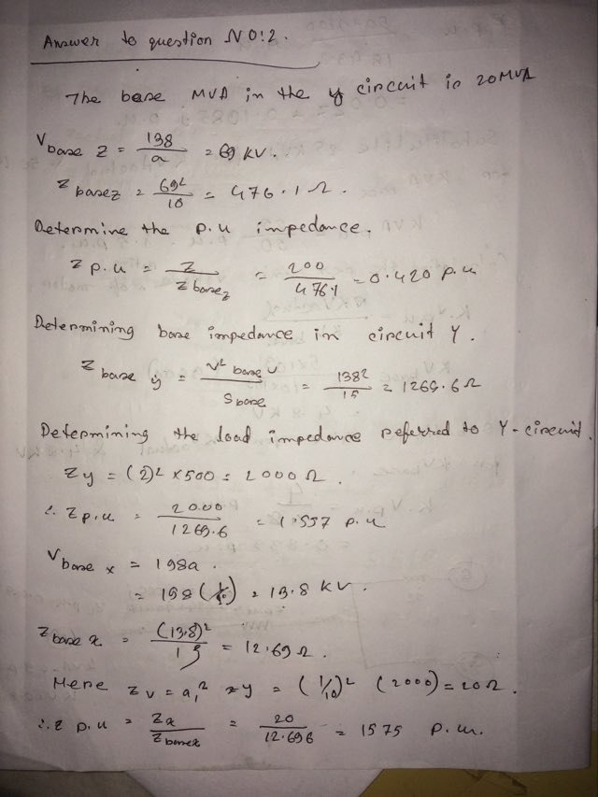

Answer to Question No: 4

